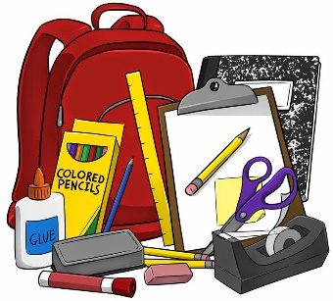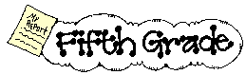
- 1 Backpack
- 1 Ruler with inch and centimeter markings
- 1 set of ear buds or headphones for iPad/computer
- 2 boxes #2 pencils
- 1 packages of glue sticks & 1 liquid- multi colors
- 10- 2 pocket folders (plain—not patterned)
- 3 pink pearl erasers
- 2 box of colored pencils (24 or more)
- 1 package pencil top erasers
- 3 1-2 inch 3 -ring binders
- 1 1-inch binder
- 5 composition notebooks
- 2 packages of dry erase markers
- 2 large boxes of facial tissue
- 1 box of Band-Aids
- 3 large containers of Clorox disinfecting wipes
- 1 package of index cards (3X5)
- 1 package of wide-ruled notebook paper
- 1 Scissor
- 2 yellow highlighters
- 1 English Dictionary
- 1 Spanish-English Dictionary (prefer Vox Compact)
- Ziploc bags (girls: sandwich size) (boys: gallon size)
- USB Flash Drive
- Book: 501 Spanish verbs

PS: Please do not label items, we share many of the supplies.

Whole School
1 Refill size bottle of hand sanitizer
1 Refill size bottle of hand soap
5 ream of copy paper
3 Rolls of paper towels
3 Rolls of Toilet paper

