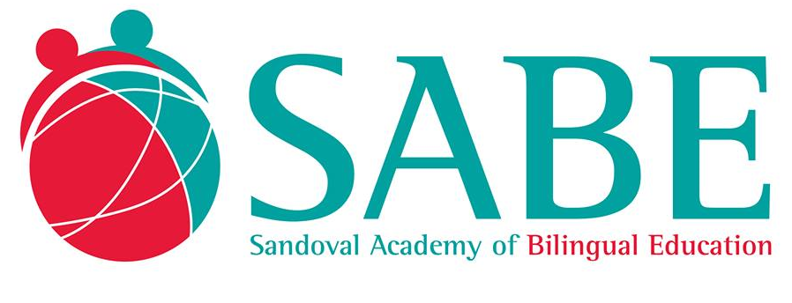
McKinney-Vento Homeless Assistance Act

Sandoval Academy of Bilingual education is committed to ensuring that homeless students have equal access to the same free, appropriate public education and services, including public preschool education, as provided to other children and youth in the District in accordance to the provisions of the McKinney-Vento Homeless Education Act, 42 U.S.C. § 11431 et seq.

Definitions.
“Homeless student” shall have the same meaning as the term “homeless children and youths,” defined by 42 U.S.C. § 11434a(2) as:

Individuals who lack a fixed, regular, and adequate nighttime residence or an individual who has a primary nighttime residence that is a supervised publicly or privately operated shelter designed to provide temporary living accommodations (including welfare hotels, congregate shelters, and transitional housing for the mentally ill); an institution that provides a temporary residence for individuals intended to be institutionalized; or a public or private place not designed for, or ordinarily used as, a regular sleeping accommodation for human beings.

This definition includes:

(1) children and youths who are sharing the housing of other persons due to loss of housing, economic hardship, or a similar reason; are living in motels, hotels, trailer parks, or camping grounds due to the lack of alternative adequate accommodations; are living in emergency or transitional shelters; are abandoned in hospitals; or are awaiting foster care placement;

(2) children and youths who have a primary nighttime residence that is a public or private place not designated for or ordinarily used as a regular sleeping accommodation for human beings;

(3) children and youths who are living in cars, parks, public spaces, abandoned buildings, substandard housing, bus or train stations, or similar settings;

(4) unaccompanied youth; and

(5) migratory children (as such term is defined in 20 U.S.C. § 11302(a)(2)(C) who qualify as homeless for the purposes of this part because the children are living in circumstances described above).

“School of origin” means the school that the student attended when permanently housed or the school in which the student was last enrolled.

“Unaccompanied youth” means a youth not in the physical custody of a parent or guardian.
“Homeless Liaison” means the staff person designated by the Superintendent as the person responsible for carrying out the duties assigned by the McKinney-Vento Homeless Assistance Act to local education agencies.

Enrollment.
To the extent possible and according to the best interest of the homeless student, the student shall remain in his or her school of origin for the duration of his or her homelessness or for the remainder of the academic year if the student becomes permanently housed during an academic year in a school district other than that of the school of origin. Alternatively, a homeless student may enroll in the school in the school zone in which the student is temporarily residing. A homeless student shall be immediately enrolled, even if the student is unable to produce records normally required for enrollment, such as previous academic records, medical records, proof of residency, or other documentation. The enrolling school shall immediately contact the school last attended by the homeless student to obtain relevant academic and other records.

To determine the homeless student’s “best interest”, Sandoval Academy of bilingual Education shall (1) to the extent feasible, keep a homeless student in the school of origin, except when doing so is contrary to the wishes of the student’s parent or guardian; (2) provide a written explanation, including a statement regarding the right to appeal, to the homeless student’s parent or guardian, if Sandoval Academy of bilingual Education sends such student to a school other than the school of origin or a school requested by the parent or guardian; and (3) in the case of an unaccompanied youth, ensure that the Homeless Liaison assists in placement or enrollment decisions, considers the views of such unaccompanied youth, and provides notice to such youth of the right to appeal.

Educational Services.
A homeless student shall be provided the services offered to other students, including, without limitation, educational services (including services provided under Title I, IDEA, and educational programs for students with limited English proficiency), program in vocational and technical education, programs for gifted and talented students, and school nutrition programs.

Homeless Liaison. The Director shall appoint a Homeless Liaison who shall ensure that:

- homeless students are identified by school personnel and through coordination activities with other entities and agencies;

- homeless students enroll in, and have full and equal opportunity to succeed in, Sandoval Academy of bilingual Education;

- homeless families and students receive educational services for which such families and students are eligible, including programs administered by Sandoval Academy of bilingual Education, and referrals to health care services, dental services, mental health services, and other appropriate services, and the parent, guardian, or unaccompanied youth is fully informed of these educational services;

- public notice of the educational rights of homeless students is disseminated where such students receive services, such as schools, family shelters, and soup kitchens;

- the parent or guardian of a homeless student, and any unaccompanied youth, is fully informed of all transportation services, including transportation to the school of origin, and is assisted in accessing transportation to the school that is selected by the student;

- coordinate with local social services agencies and other agencies or programs providing services to homeless students and their families, and with other school districts on interdistrict issues, such as transportation or the transfer of school records;

- assist a homeless student in obtaining necessary immunizations or records;

- monitor and carry out the enrollment dispute resolution process as expeditiously as possible after receiving notice of the dispute; and

- develop procedures by which the District and the Homeless Liaison will implement and comply with this Policy.

Notice. Written notice shall be provided to the parent or guardian of a homeless student or the unaccompanied youth at the time any homeless student seeks enrollment in the Sandoval Academy of bilingual Education and at least twice annually while the homeless student is enrolled in the Sandoval Academy of bilingual Education, that

- shall be signed by the parent or guardian or the unaccompanied youth;

- sets forth the general rights provided to the homeless student;

- specifically states the choice of schools homeless students are eligible to attend; that no homeless student is required to attend a separate school for homeless children or youths; that homeless children and youths shall be provided comparable services, including transportation services, educational services, and meals through school meals programs;

- homeless students should not be stigmatized by school personnel;

- provides contact information for the Homeless Liaison and the New Mexico Coordinator for Education of Homeless Children and Youths;

- describes the dispute resolution procedures that a parent, guardian or unaccompanied youth may follow to initiate a complaint with the school principal or District Homeless Liaison in the event that there is a dispute over enrollment, services, or other rights arising under the McKinneyVento Act; and

- is provided in a manner and form understandable to such parent or guardian or unaccompanied youth, including, if necessary and to the extent feasible, in the native language of such parent or guardian or youth.

- The notice also shall include a simple dispute resolution form that the parent, guardian or unaccompanied youth may use to initiate a complaint with the school or District Homeless Liaison.

Dispute Resolution. Disputes addressing the enrollment, transportation, and other barriers to education of children and youth experiencing homelessness may be initiated by parents, guardians or unaccompanied youth by submitting a complaint on the dispute resolution form contained in the above-described notice to either the school Director or the District’s Homeless Liaison. Pending resolution of the dispute, the student shall be immediately enrolled in the school in which enrollment is sought and the student shall be provided services for which he/she qualifies.

- The complaint must be (i) written; (ii) signed by the complaining party or his/her designated representative; (iii) contain a statement that Sandoval Academy of bilingual Education has violated a requirement of federal statute or regulation; (iv) contain a statement of the facts on which the complaint is based and the specific requirement alleged to have been violated; and (v) the relief being requested.

- Upon receipt of the initial complaint, the school Director or Homeless Liaison shall provide the complaining party with written confirmation of the receipt of the complaint and a notice of rights. The notice of rights should include:

- contact information of the school Director, the District’s Homeless
Liaison and the PED homeless liaison, along with a brief description of their roles;
- a step-by-step description of how to follow the dispute resolution process;
- notice of the right to immediately enroll in the school of choice pending resolution of the dispute and notice that immediate enrollment includes full participation in all school activities;
- notice of the right to obtain the assistance of advocates or attorneys;
- notice of the right to appeal to the New Mexico Public Education Department (PED) if the district-level resolution is not satisfactory;
- the timeliness for resolving district and PED-level appeals; and
- notice of the right to provide written or oral documentation to support their position.

- The Director or Homeless Liaison shall investigate the initial complaint and provide a written decision within ten (10) calendar days from the receipt of the complaint. The written decision, if adverse to the complaining party, shall inform the complaining party that he or she may appeal the determination to the District’s Homeless Liaison by providing a written statement appealing the decision within three (3) school days from the date of the Director’s decision. Upon receipt of a party’s notice of appeal, the principal shall promptly forward the following information to the District’s Homeless Liaison:
- the school name, address, phone and fax number;
- the student’s name, identification number, grade, and address;
- parent, guardian or complaining party’s name, relationship to student, address and phone number;
- name of school child or youth chooses to be enrolled in pending resolution of the dispute;
- reason for complaint;
- whether school enrolled in is school of origin;
- signature of parent, guardian or complaining party; and
- the principal’s decision on the complaint.

D. Upon receipt of the initial complaint or appeal from a determination by the school Director, the Homeless Liaison shall investigate the complaint and provide the complaining party with a written determination within ten (10) calendar days. The Homeless Liaison’s decision shall be Sandoval Academy of bilingual Education’s final decision. The written decision shall include all factual information upon which the determination is based and the legal basis in support thereof. If the decision is adverse to the complaining party, the decision and all supporting documentation shall be forwarded to the New Mexico PED’s homeless liaison within five (5) calendar days from the date of issuing the Sandoval Academy of bilingual Education’s final decision. The complaining party may choose to appeal to the PED directly within five (5) calendar days of the District’s final decision.

