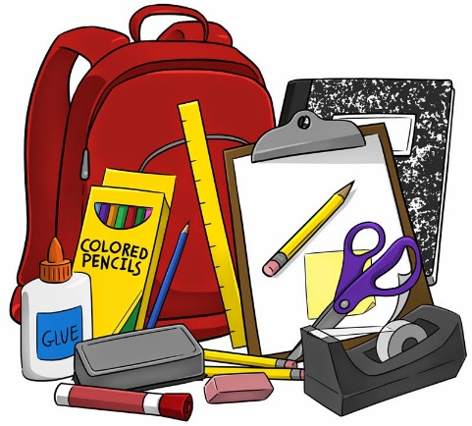
1 Backpack
1 Ruler with inch and centimeter markings
3 boxes of Ticonderoga #2 pencils
3 Pkgs. of Glue Sticks only 2 if a 4 pack
1 4 Pack of pink erasers
1 Carton of pencil top erasers
1 Bx. of colored pencils 24 or more
1 1 ½ inch 3 ring binder
1 1 inch binder
2 Black marble composition journal books with a picture portion on top
5 Wide ruled Spiral notebooks (1 red, 1 blue, 1 yellow, 1 green, 1 purple)
2 Pkgs. of Expo dry erase markers at least 1 black and then other colors
2 Large boxes of facial tissue (1 for Fall and 1 for Spring)
1 Box of Band-Aids
2 Large containers of Clorox Disinfecting Wipes
1 Sharpie black permanent marker
1 Pkg. 3x5 Index cards
2 Pkgs. of wide ruled notebook paper (1 for Fall and 1 for Spring)
1 Box of Zip lock bags (Girls Gallon size, Boys Sandwich Size)
1 Pair of Scissors
1 Pkg. of Water colors
2 Boxes of 24 crayons (1 for Fall and 1 for Spring)
2 Bottles of liquid glue (1 for Fall and 1 for Spring)
1 Pencil box
8 2 Pocket folders (2 blue, 2 yellow ,2 green, 2 orange)
1 package water based markers (optional)
Whole School
1 Refill size bottle of hand sanitizer
1 Refill size bottle of hand soap
5 ream of copy paper
3 Rolls of paper towels
3 Rolls of Toilet paper

